RegEx in Python

A RegEx, or Regular Expression, is a sequence of characters that forms a search pattern. Python has a built-in package called re, which can be used to work with Regular Expressions.

## RegEx Functions

|  |  |
| --- | --- |
| Function | Description |
| search | Returns matching object if there in the string |
| findall | Return all list matching |
| split | Returns a list of matches where the string has been split |
| sub | Replace matches with string |

Example: Peoples brain in Spain.

## Metacharacters

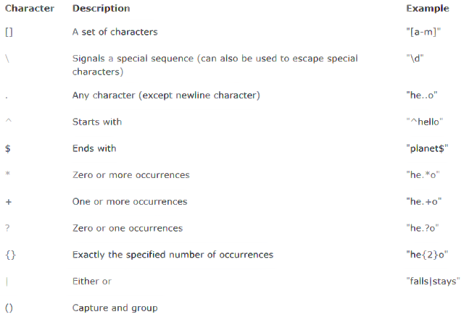

## Special Sequences

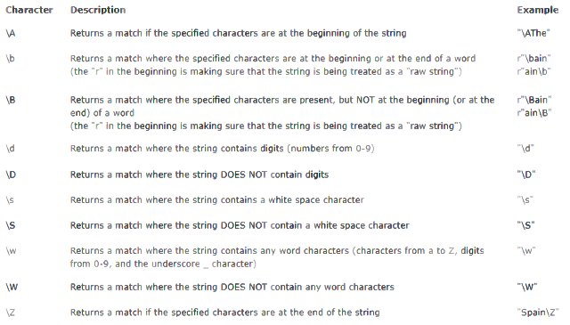

## Sets

